**PRACTICAL NO. 6**

**AIM: Replication using MongoDb**

**Step 1: Create folder in c drive**

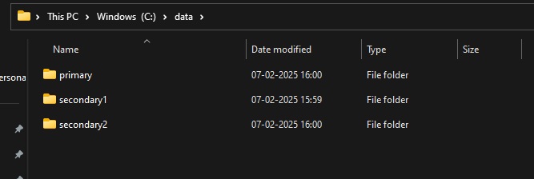

**Step 2: Go to Windows PowerShell ISE>New file(make three of them/ type same command with different port and path)**

Commands:

mongod --port=2717 --dbpath="C:\data\primary" --replSet="test-replica-set"

mongod --port=2727 --dbpath = "C:\data\secondary1" --replSet="test-replica-set"

mongod --port=2737 --dbpath = "C:\data\secondary2" --replSet="test-replica-set"

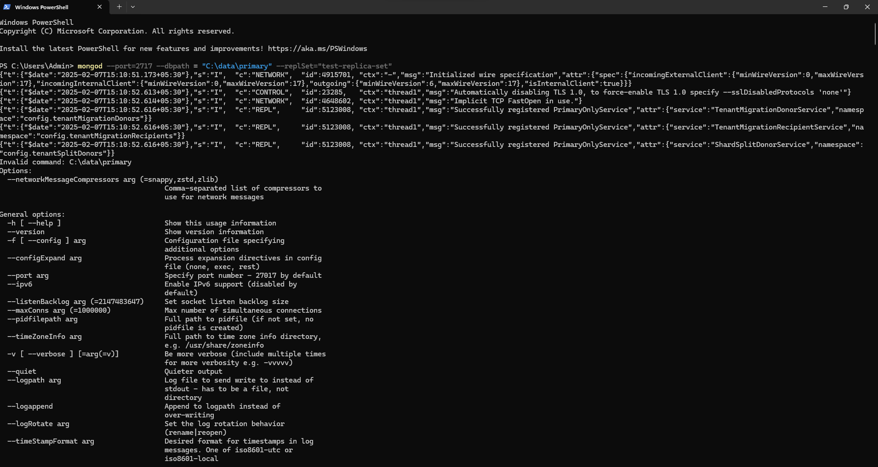

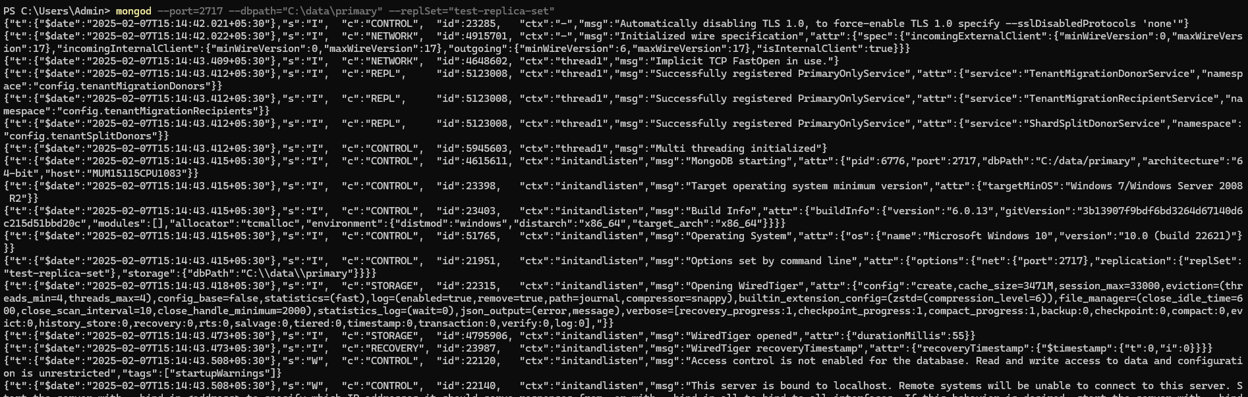

Step 3: New window

Commands:

mongosh --host="localhost:2717" (make new 2 windows with other localhost)

rs.initiate()

rs.add({“host:localhost:2727”});

rs.status()

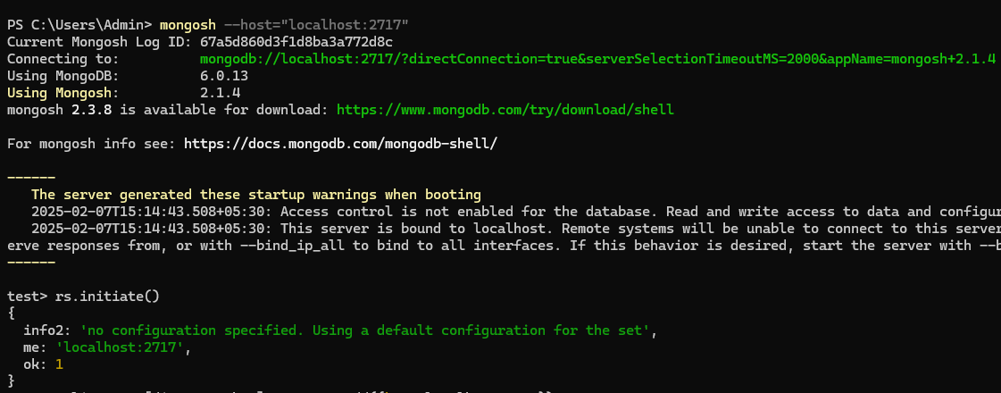

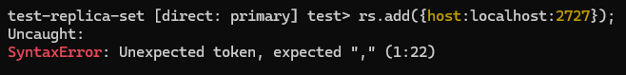

Error: rs.add({“host:localhost:2727”});

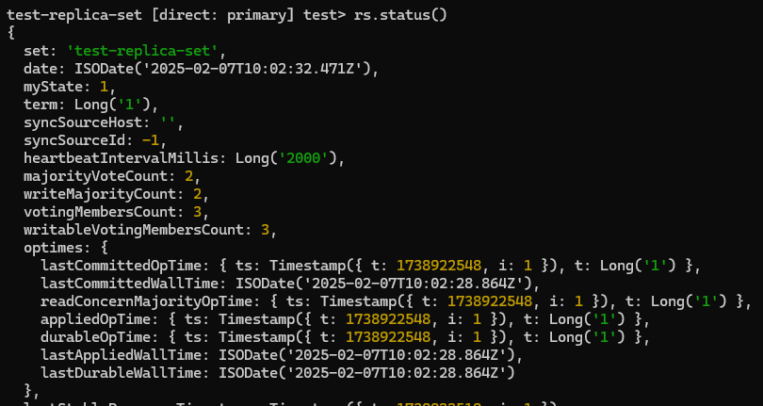

1. show dbs
2. use practice
3. db.users.insert({name:"Shruti"})
4. db.users.find()

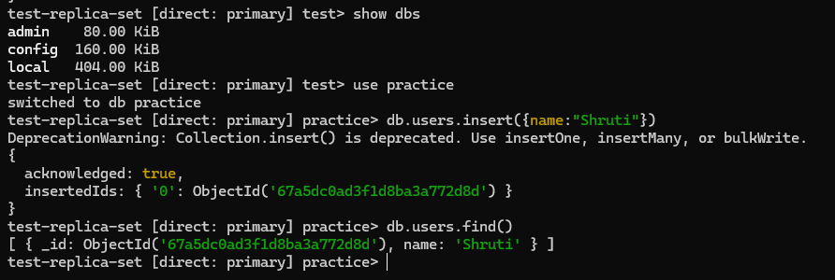

Now repeat I, ii, iv for rest 2 windows

Localhost:2727

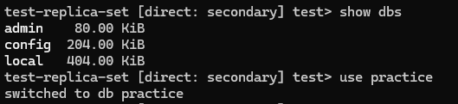

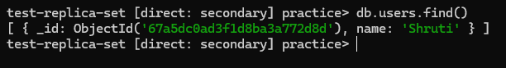

Localhost:2737

